March 2021 Press Release 3

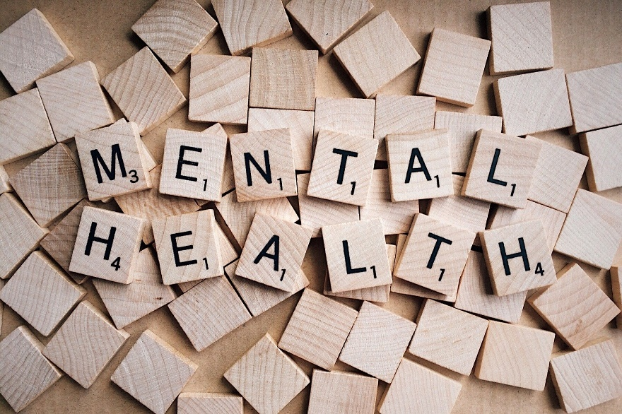
Our training programs are here!
Restorative justice can have an empowering effect on the mental health patients, breaking the stereotypical power-authority relationship, between the therapists and the patient while facilitating the relief of mentally ill and their social restoration. The potential and benefits of combining therapeutic art with restorative justice are still not translated into educational material and programmes, leaving many adult learners and professionals in the field unaware. As a response to that, we are happy to announce that the training programs: “Restorative art in mental health structures” and “Art as a relief and a restorative justice tool for mental health” are officially launched and ready for piloting!

Training program: Restorative art in mental health structures
This e-course is the second intellectual output (IO2) of MHM, and it’s addressed to mental health professionals, mental health structures’ coordinators, mental health carers, other health care practitioners and restorative justice practitioners. The program aims to introduce mental health professionals to the values of restorative justice and give them a methodological approach that combines the therapeutic form of art with the restorative values and the power of art as a means of restoring injustice. Furthermore, the target group will be trained on creative art therapeutic approaches and the many expressions that these approaches might take within mental health structures for the benefit of the people suffering mental illness. The ultimate objective of the program is to lead to a healing, but also a self –representation process for the people living in mental health structures. You can register for the course here!

Training program: Art as a relief and a restorative justice tool for mental health
This e-course is the third intellectual output (IO3) of MHM and aims to train artists and professionals working in the artistic and cultural sectors on how to use the transformative power that restorative justice art might have in the lives of people with mental health issues. Through this training programme, participants will discover how art can be used as a healing tool not only to relieve people facing mental illness, but also to promote their social restoration and improve their self-representation. Participants will explore how their art can have a meaningful social impact in supporting people with mental health conditions to regain their “voice”, while creating new potential professional prospects and paths. You can register for the course here!

Both e-courses are based on the findings of Intellectual Output 1” Training Manual: The use of restorative art in mental health structures”. The training programmes will also be piloted in all participating countries and across Europe. Also, successful completion of each e-course will lead to a CPD (Continuous Professional Development) Certification.

Objectives of the project

MHM aims to enhance the skills, knowledge, and experience of mental health professionals using art and restorative justice values. MHM also aims to train artists to use art in order to facilitate the relief of mentally ill patients and their social restoration. The ultimate goal is to create innovative tools that enhance the healthcare provision and self-representation of those who live within mental health structures. Thus, the main aim is to create a methodological approach that puts together the benefits of art therapy with the values of restorative justice. MHM will also design and accredit e-courses that will enhance the skills and knowledge of adult learners, supporting in this way the setting up of, and access to upskilling pathways.

The consortium includes 6 partner entities, the coordinator Restorative Justice for All (UK) and five other partners: Center for Social Innovation-CSI (Cyprus), Kinonikes Sineteristikes Drastiriotites Efpathon Omadon - EDRA (Greece), Lélekben Otthon Közhasznú Alapítvány (LOKA) (Hungary), Fundacion INTRAS (Spain), and Anotati Scholi KAlon Technon -ASFA (Greece).

Find us on the Web and social media!

Visit https://mentalhealthmatters.eu/ to find out more about our project, to get informed about our news and activities, to read our publications and stay tuned to get informed about the trainings and the online tools that will be developed in the context of this project.

You can also find us on Facebook at https://www.facebook.com/MHMerasmus. Through our Facebook page, you can have access to continuous updates on all the developments of the MHM project, as well as news related to the field.

